CITY OF ELLSWORTH NEWSLETTER JUNE 2021
The elected officials of the Ellsworth City Hall will be holding an Open House on Saturday, June 12th, 2021 from 2:00PM – 4:00PM with coffee, juice & cookies. You may also view the new city shop (next to the fire hall). Please join us as we celebrate!

FAMILY FUN DAYS: The Ellsworth Community Club has put together a fabulous

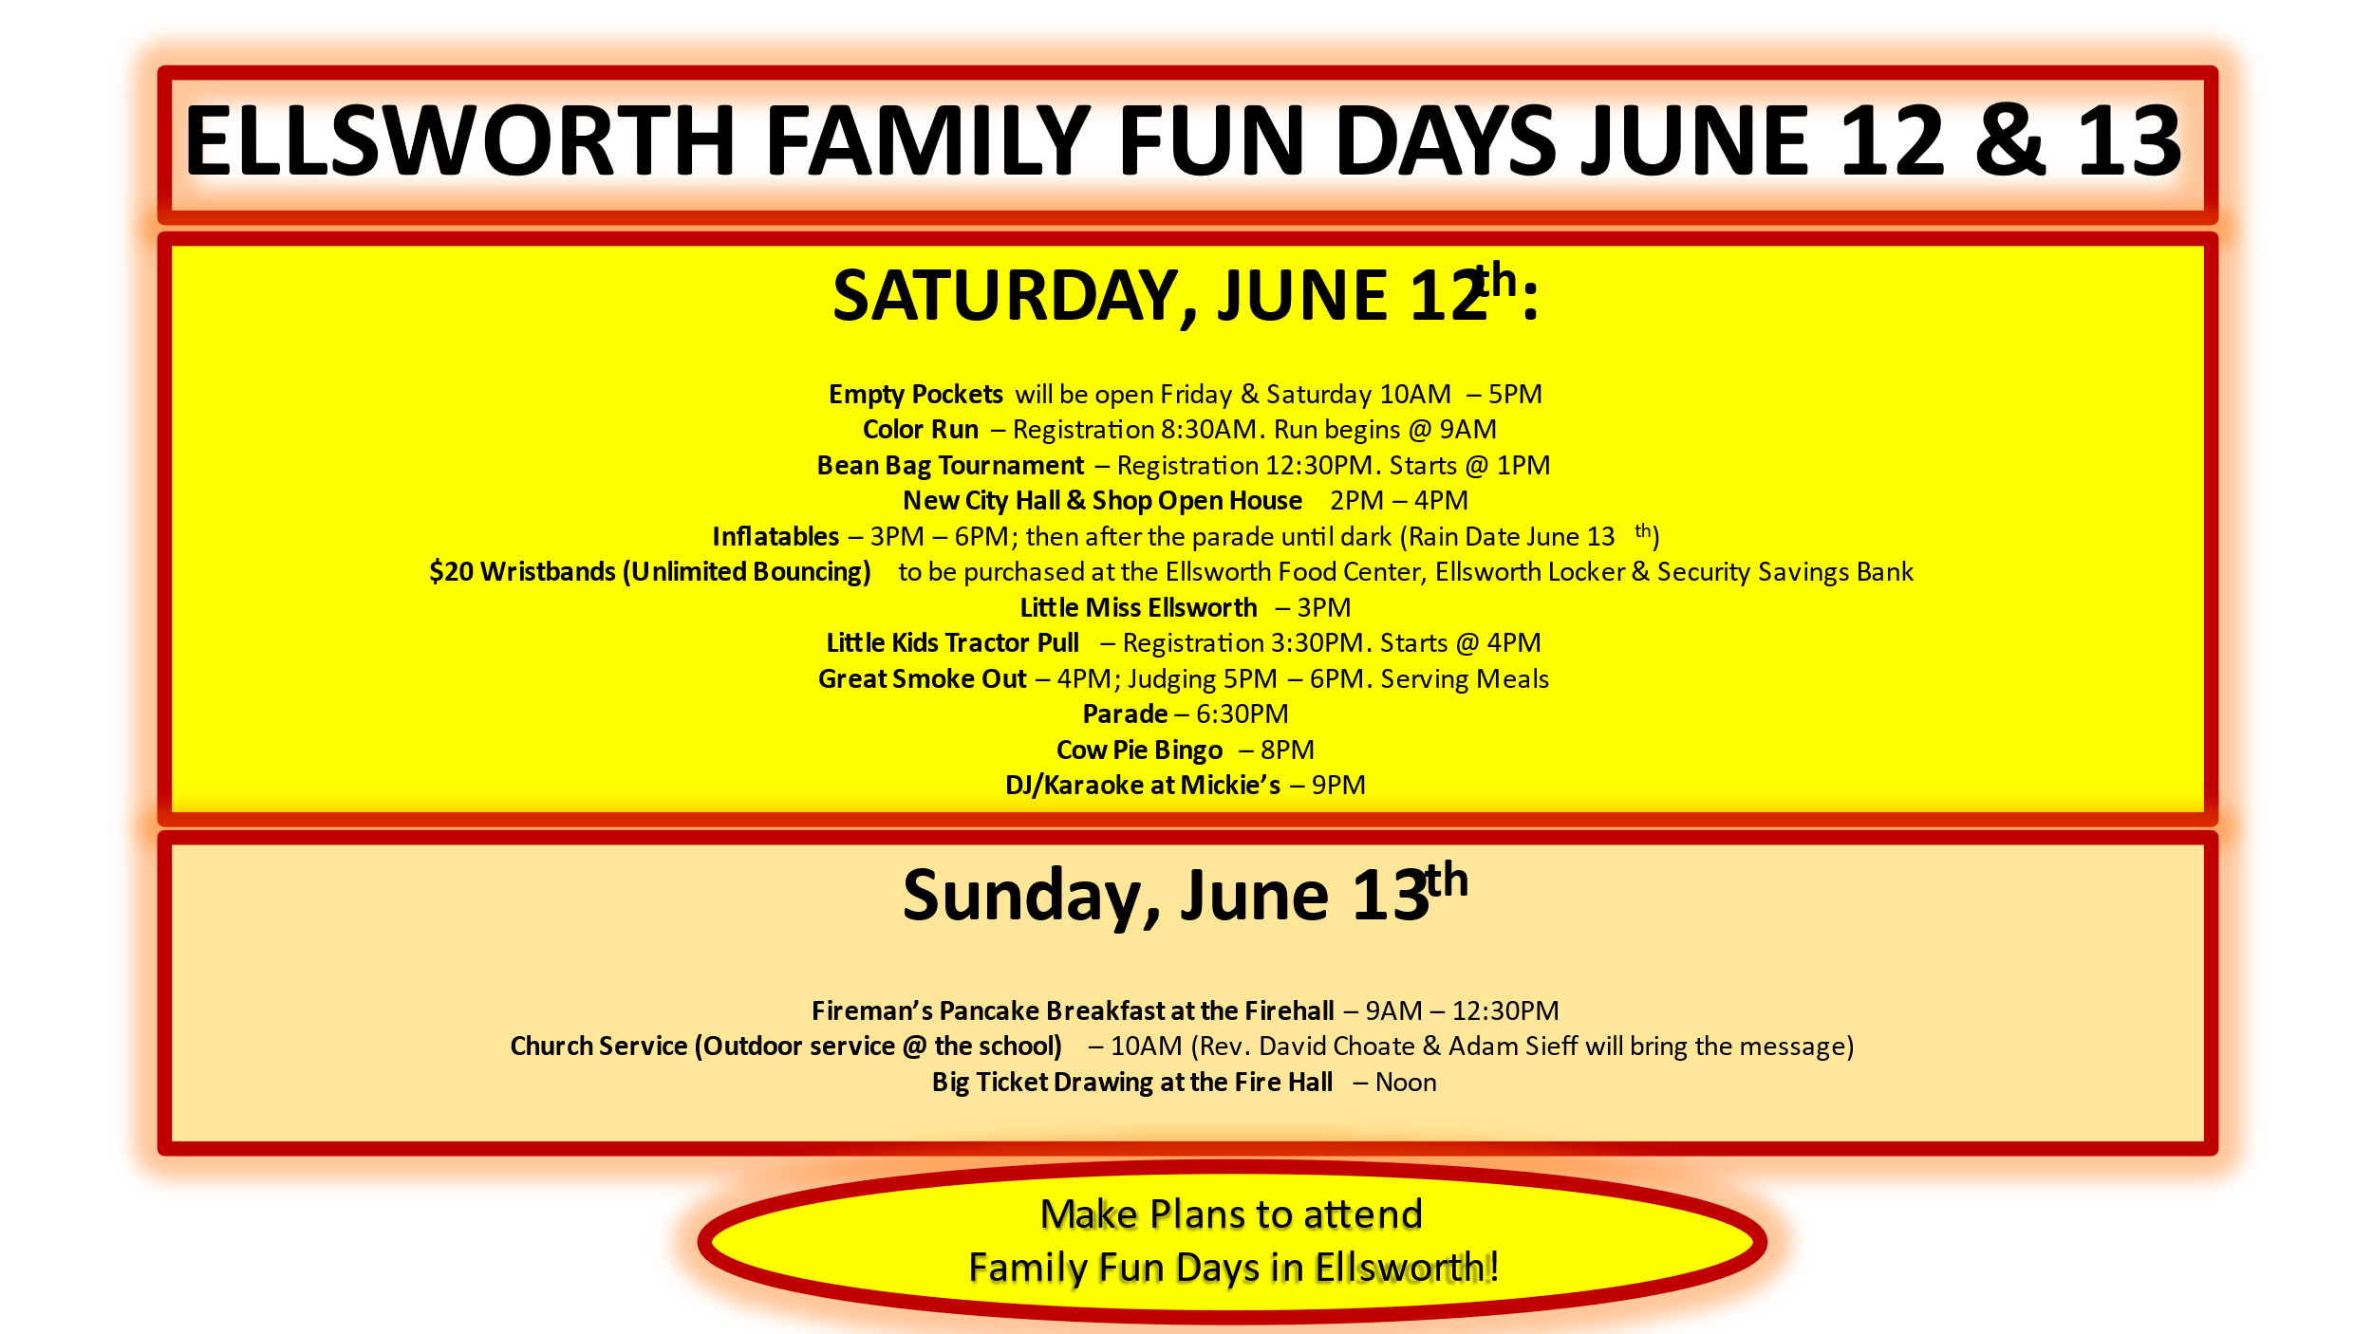

The Ellsworth City Hall, is now open! If you are interested in renting the community room, it holds 70-80 people! We have several families/businesses that have reserved this room already. If you want more information, contact city hall or go online to the city webpage www.ellsworth.mn.citygovt.org.

On Monday, May 10th, 2021, Oath of Office was read to Chad Schultz by Mayor Colette Smythe, to fulfill the two-year term as City Councilmember. (End December 31st, 2022)
Chad Schultz, City Council Member
The city has implemented the Zoning Ordinance in March. This is not a building ordinance; this is a land use ordinance. What will go on the land? How will you use the land?
LAND USE APPLICATION & PERMT ~ If you build an addition, you will need to fill out a permit application. If you build a fence, you will need to fill out an application. If you move something on your property, you will need a permit application. The application will be reviewed by the Ellsworth City Council, therefore, plan at least 30 days ahead as the city council only meets monthly.
The Campground is open! Contact your friends & family and ask them to join you for Family Fun Days! A picnic table, a fire pit and electric for each space. Reasonably priced.

You may view the ordinance on the city webpage www.ellsworth.mn.citygovt.org
Under Useful Links. Scroll down to Land Use Zoning Ordinance #10. Or, you may request a copy and application at the Clerk’s Office.

THISTLES, AND WEEDS GROWING 6” OR MORE ON YOUR PROPERTY NEED TO BE MOWED, TRIMMED, OR SPRAYED. Written and signed complaints have been given to the elected officials. These complaints will be addressed and taken care of by the Ellsworth City Council and the Nobles County Sheriff’s Office as tickets may be written if needed. Please do your part and take care of your property. Let us ALL make the City of Ellsworth a better place to live.

Please do not dispose any disposable wipes into your toilet as this will plug up your sewer system. On the southeast part of town, wipes have been found in the sewer. Please do your part and throw them in the garbage and NOT the toilet. Thank you!

CITY FACEBOOK & WEBPAGE: Watch the Ellsworth Facebook page (Like us on Facebook: City of Ellsworth, Minnesota) and, the city website www.ellsworth.mn.citygovt.org for updated information.
~ The Ellsworth City Council

