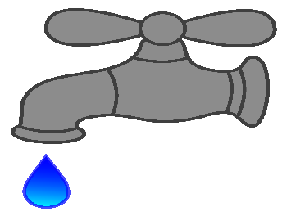
Delinquent Water Fees

FAMILY FUN DAYS WILL BE HELD THE WEEKEND OF
JUNE 10TH, 11TH, & 12TH

Watch for updated news on what this weekend will entail!
Contact Karla Kvaale if you are interested in being a vendor at the craft show on Saturday, June 11th. 507-370-0098
have been set by the
Ellsworth City Council
for $30.00 if you are
delinquent in payment on
the 25th of each month.

$9.72 Minnesota Department of Health Annual Fee

This fee has been added to your March 2022 water bill.
It is a fee implemented by the Minnesota Department of Health that was increased by the Legislature in 2019 and put into effect January 1st, 2020.
The increase will be spent on lab costs for drinking water tests. Much of the rest will be used to support staff who conduct inspections, collect, and analyze required water samples, and provide technical assistance, training, and support to enhance water systems’ capacity to meet the requirements of the Safe Drinking Water Act.

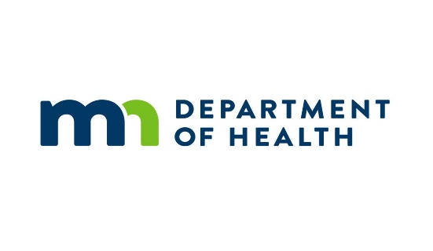
City Campground
If you are planning on coming to Ellsworth for Family Fun Days or just to visit, the city has a new campground with 10 electrical hook-ups; fire ring; picnic table; shower/restroom (built in 2018); playground equipment; softball diamond (if not in use by local teams); and the shelter house if not reserved (Contact Parkview Manor Nursing Home for reservation 507-967-2482).
A sewer dump station has been added and is on the northeast side of the campground.
The Campground is open from April 1st – October 31st.
$15.00 dollars per night, per site for campers. (Tax included)
$10.00 dollars per night, per tent in designated area only. (Tax included)
Camping Rules & Regulations available upon request.

